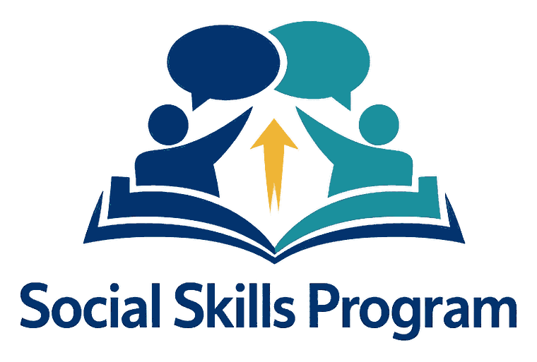
Lesson Plan — Perspective Taking, Skill 1
Know That Others Think Something Different
Social Skills Program • Ages 12–16 • Special Education
Objective: Students will notice that another person can want, like, or think something different from them, and say so without calling it wrong.
Duration: 30 minutes, then narrated by every adult across the day
Materials:
- Do / Not Yet poster for this skill, where one exists
- Staff phrase card — one per staff member
- All-day plan — one per role
- Whiteboard, and real moments from the day

PHASE | WHAT HAPPENS
Warm-Up / Hook  5 minutes | 1. Notice it happening  Activity  Ask the group one question with no right answer — best food, best seat, best trip — and write every answer on the board.  Do not rank them or comment on them.  Same question. Different answers. Nobody is wrong.
Direct Instruction / Modelling  10 minutes | 2. Know That Others Think Something Different  What this means  - Other people can want a different thing than you want  - Other people can like something you do not like  - Two people can see the same thing and think differently about it  - Different is not the same as wrong  Teach  - Two people can want different things at the same time  - Two people can like different things and both be right  - You cannot tell what someone wants by checking what you want  - “Different” and “wrong” are not the same word  What the teacher can say  “He likes something different.”  “Different, not wrong.”  “What do you think he would say?.”
Guided Practice  10 minutes | 3. Practise it together  Activity  Each student guesses what the boy next to him would answer, then checks.  Coach for guessing rather than assuming.  “What do you think he would say?” — then ask him.
Independent Practice  5 minutes | 4. On his own  Activity  Each student names one thing a friend likes that he does not like himself.  Staff note who could only give his own preference back.
Wrap-Up & Review  5 minutes | 5. Review  Ask  - What does ‘different, not wrong’ mean?  - Name one thing your friend likes that you do not.  - How can you find out what someone wants?  Key takeaway  He likes something different.

Games
Pick one. Any of these can replace the guided practice or fill a second session.
1. Same Question, Different Answers
The group in a circle, whiteboard ready.
- Ask a question with no right answer.
- Write every answer up without ranking them.
- One point for guessing correctly what your neighbour would say.
- One point for noticing a difference between two answers.
Never let an answer be laughed at. The lesson collapses if it is.
2. Would He Pick It?
Two objects or two activities held up.
- Each student picks his own, then guesses a named friend's pick.
- The friend says which he actually wanted.
- One point per correct guess — no points lost for a wrong one.

Notes for Staff
- Every adult narrates the other person’s view out loud: “He doesn’t know that yet.”
- Never ask “how would you feel?” as a correction — it turns teaching into telling off.
- A wrong guess is still practice. “Good guess — let’s ask him” beats “no, that’s not it.”
- Use real moments as they happen rather than saving it for the lesson slot.
- Progress here is slow and uneven. A student can do this on Monday and not on Tuesday.

